DATA 301 Notes October 21st

Project

* Come up with a question relevant to the dataset for the milestone
* Have it done by Friday
* Research question—what question do you want answered with your dataset
* Check 538 got more datasets

Lab 4—to be

Pandas

* Def—specify functions in python
  + Def (name of function)
  + E.g def square_and_print
  + Return – returns value
* 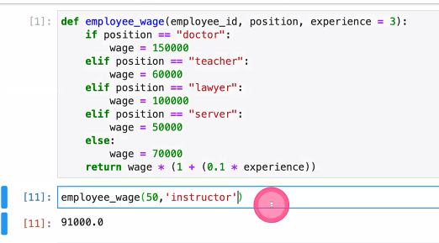
* READ lecture 7 and do modules 6,7,8
* Data.dropna (drops NaN values)
* Inplace—usually set to false
  + Can be used to replace NaN values